DAY14

Class Exercise 1

POST MAPPING

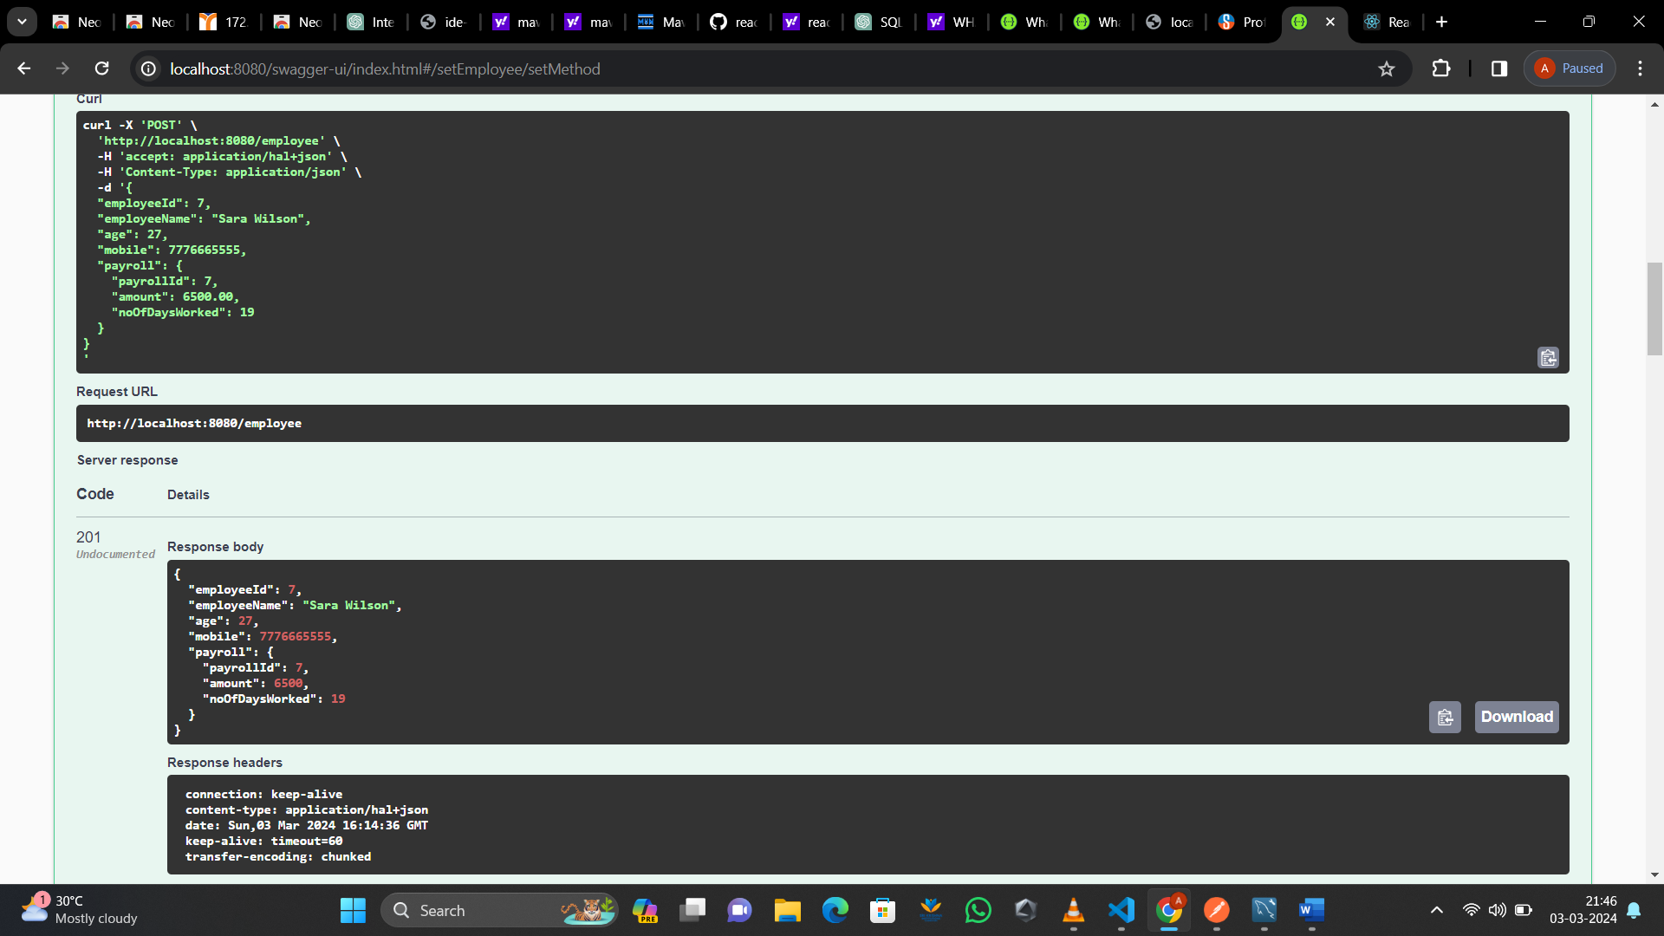

GET MAPPING

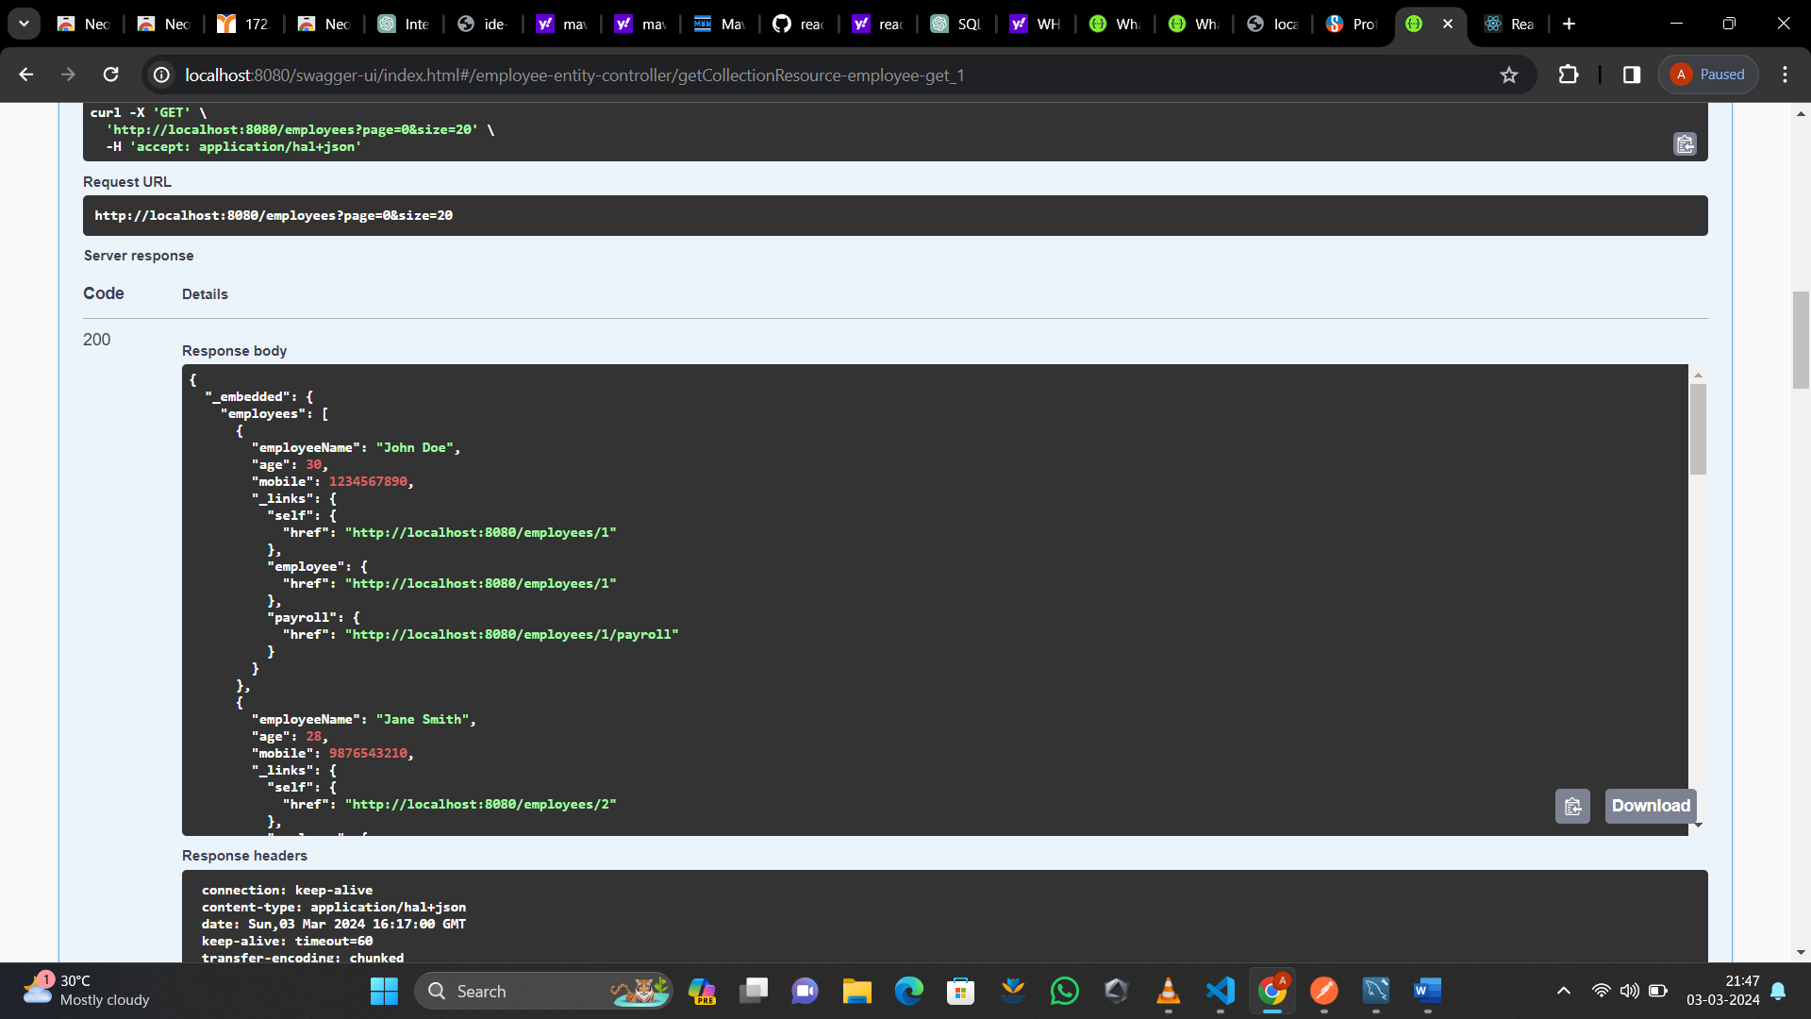

GET MAPPING BY EMPLOYEE ID

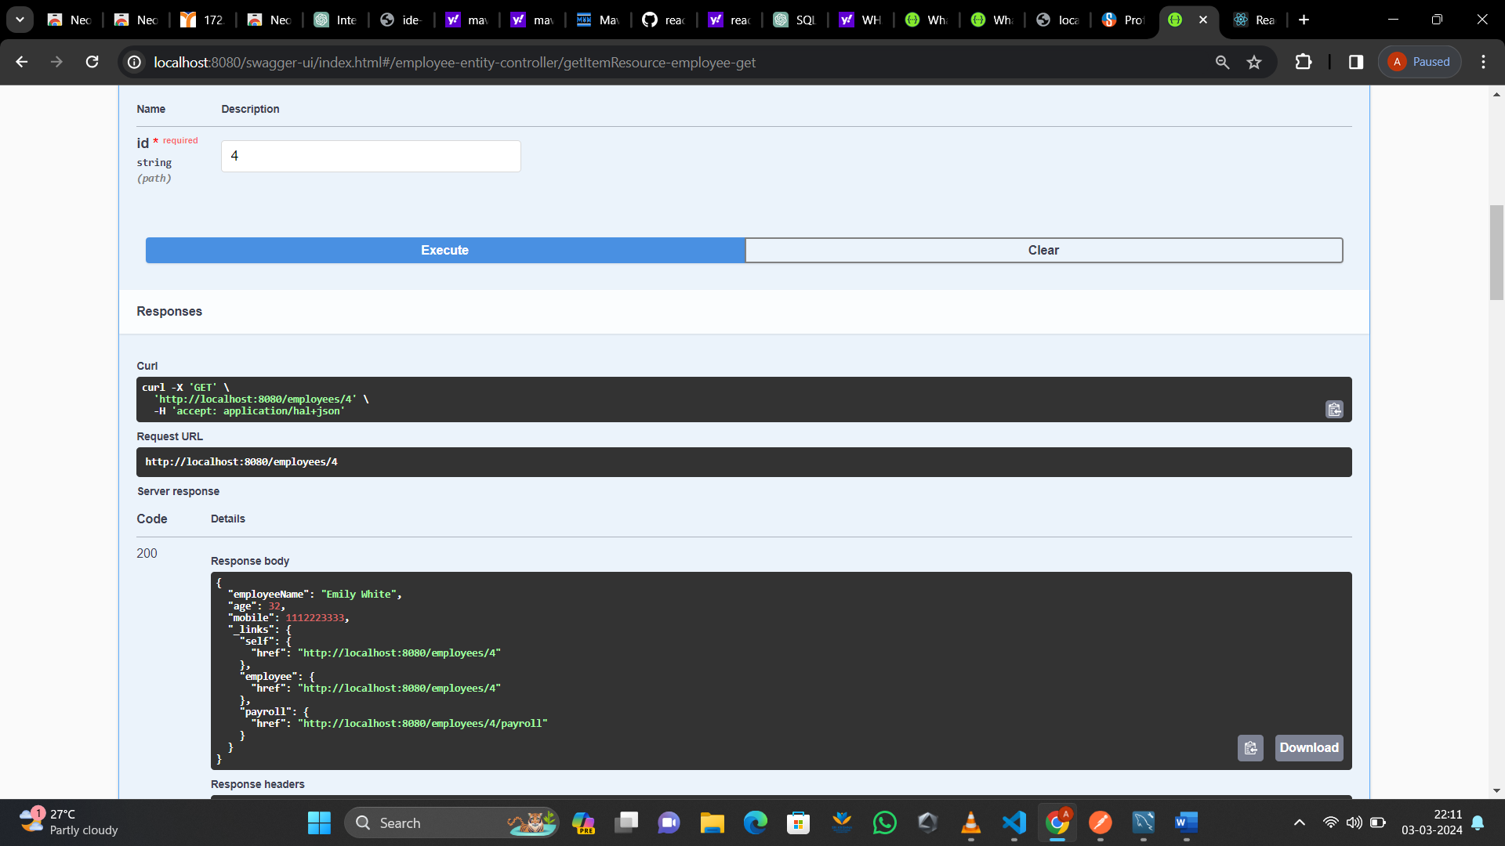

POST MAPPING BY EMPLOYEE ID

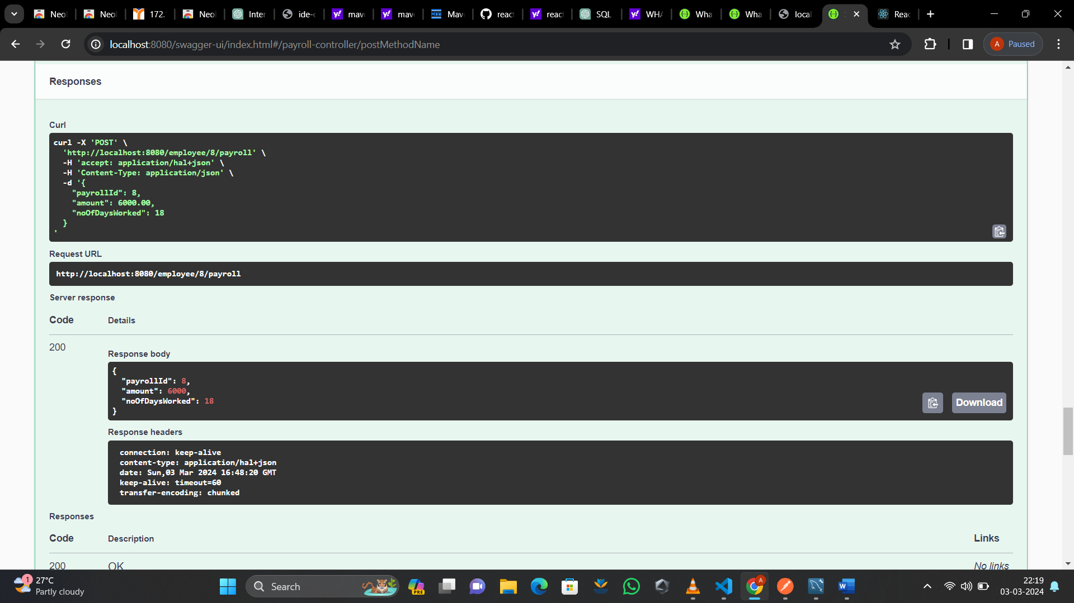

GET MAPPING BY EMPLOYEE ID PAYROLL

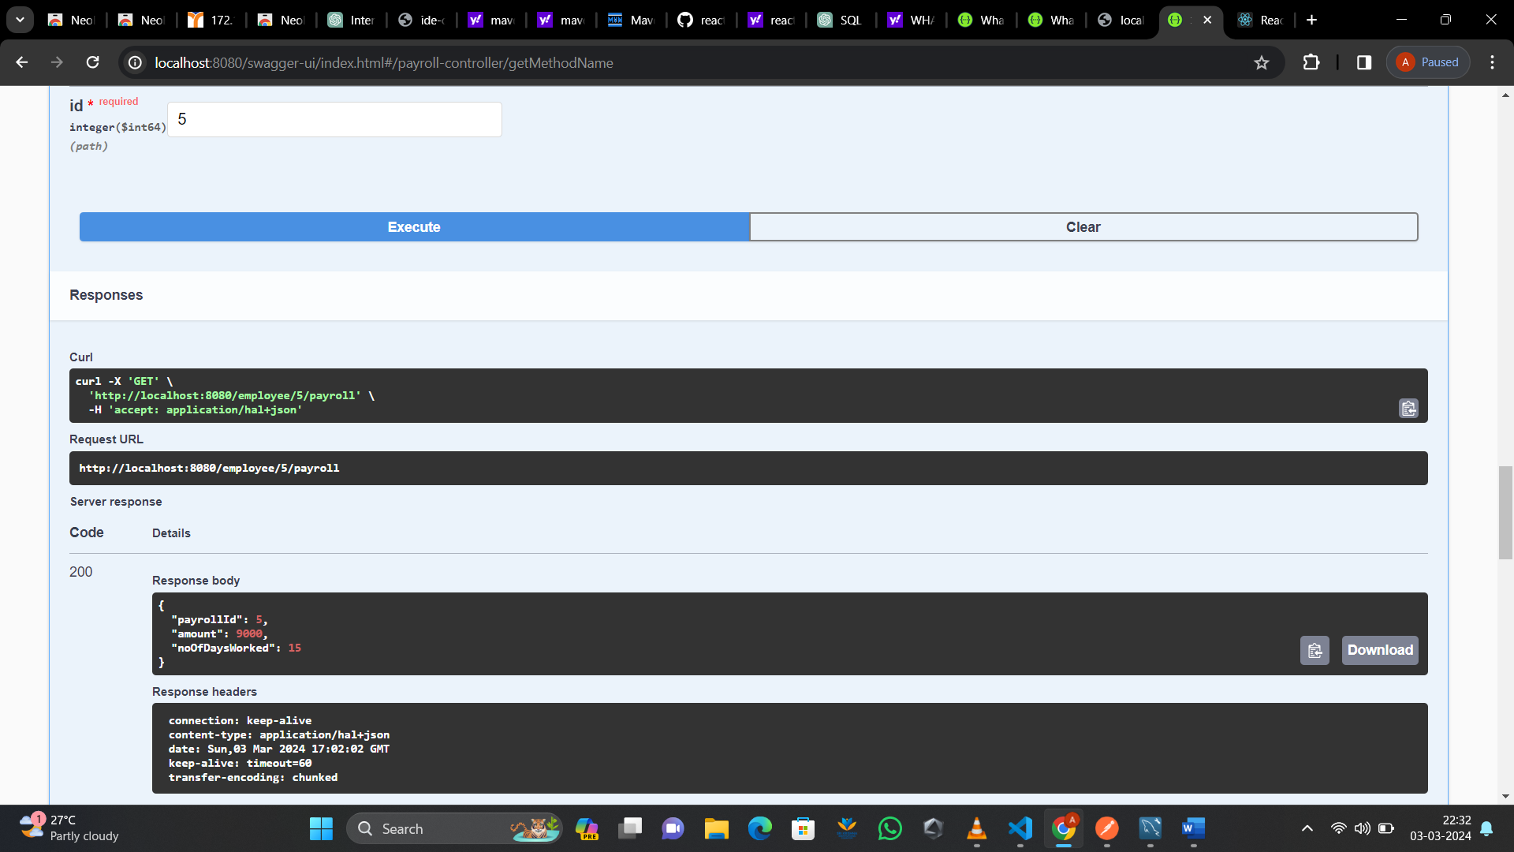

CLASS EXERCISE 2

POST MAPPING

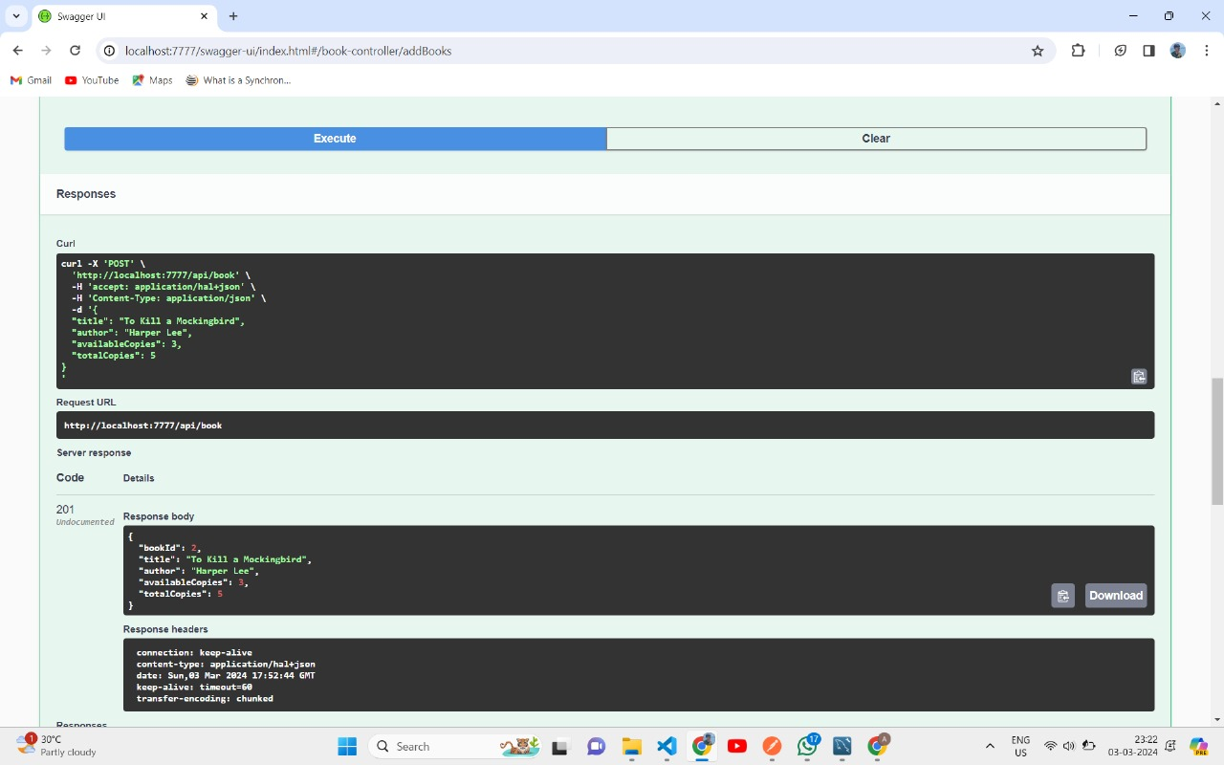

GET MAPPING

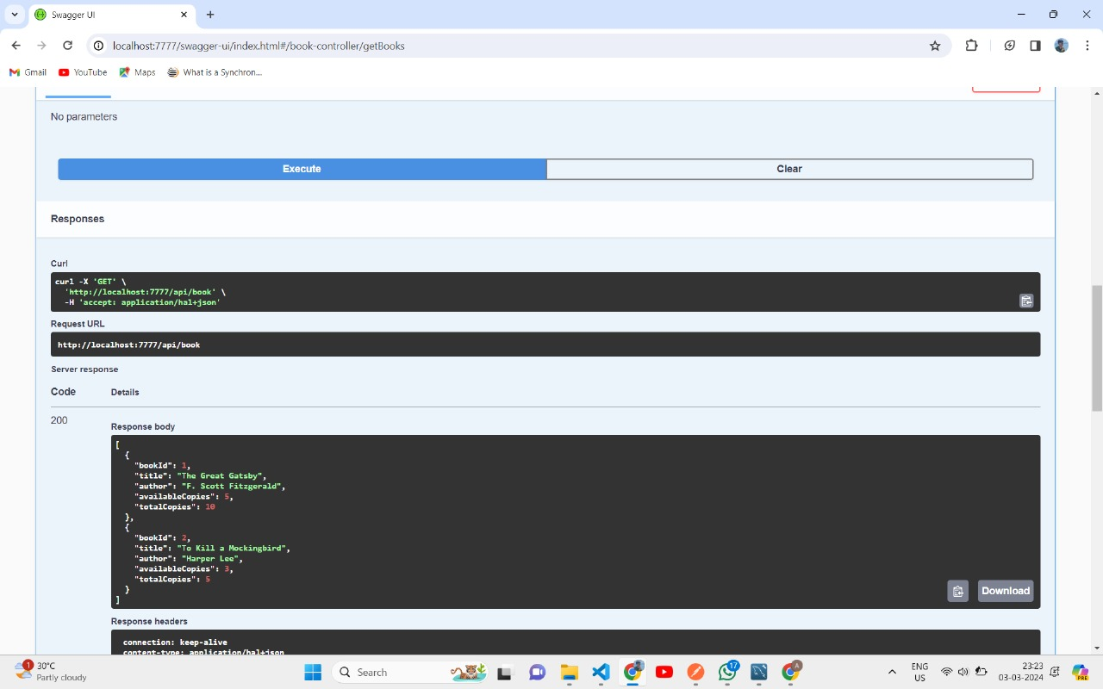

GET MAPPING BY BOOK ID

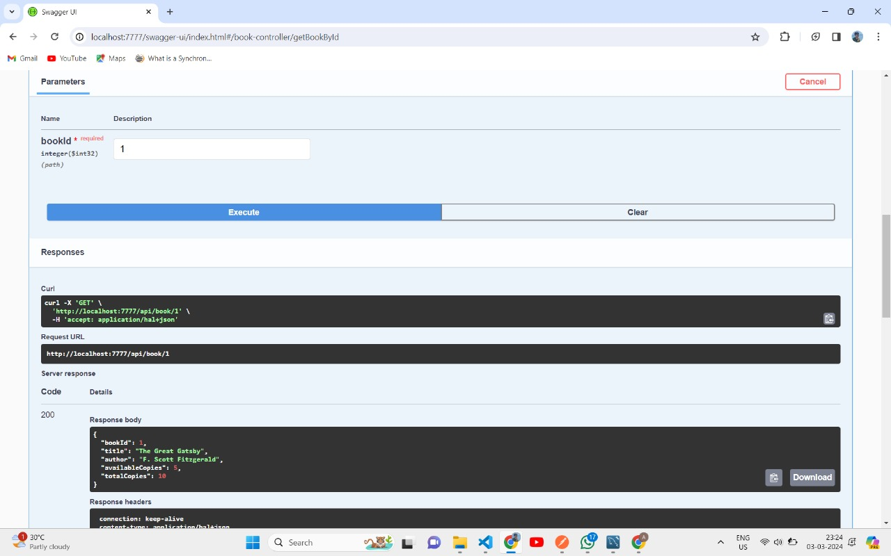

PUT MAPPING BY BOOK ID

